Excel Data Analysis – HW 1

Nick Hoyer

Given the provided data, what are three conclusions we can draw about Kickstarter campaigns?

1. **Kickstarter is not the platform for launching your latest Journalism Project**. Of the 24 campaigns launched in the Journalism category, all 24 were cancelled and unsuccessful, with an average percent funded around 5%.
2. The **month of December is not optimal for launching campaigns on Kickstarter**. In this sample set, the campaigns launched in December actually failed more frequently than succeeded – 118 failed vs. 111 succeeded.

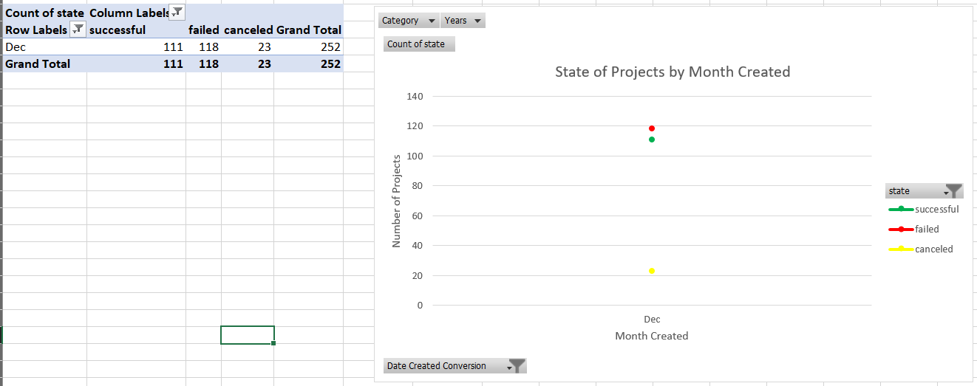

1. **Campaigns in the** **Music category are highly successful** on the Kickstarter platform. 77% of the Music campaigns that had been completed at the time of data collection were successful campaigns and the average percent funded for the category was 538%! The sub-categories of Rock, Pop, Electronic, Classical, and Metal were 100% successful for all completed Music campaigns.

What are some limitations of this dataset?

* This dataset does not remove backers that donated large amounts of money to campaigns for the average donation amount. In many cases, founders of Kickstarters allocate their own personal funds to their campaign to make it appear as though the campaign has momentum. Removing these outliers could provide more clarity into the average amount that an impartial, un-biased donor contributed to the campaigns.
* This data set looks at campaigns geographically by country, but it does not take into consideration that campaigns started in certain cities or regions of a country may be more likely to be funded.

What are some other possible tables and/or graphs that we could create?

* As a Kickstarter founder, I looked for ways to get our campaign to qualify for a “Spotlight.” An interesting analysis would be comparing the success rates of projects that are tagged as a Spotlight to those that are not. This could include the percentage of funds raised to the goal and the total time the campaigns ran.
* Campaign success based on year – as Kickstarter grows/shrinks as a platform (total # of backers), are projects funded more frequently? Additional analysis could include identification of outside factors like the success of GoFundMe as a platform. Are there additional variables that decrease the chances of a successful campaign?